Welcome you to use new version LED programming software LED player for Seekway series smart LED controller.
* Double click the SETUP file to install the software to your computer, you can install it to any folder, like desktop, or the disk not c:,
* The software is not allowed to install to C:.
* If the software language is Chinese, you can change it to English by following the steps below:
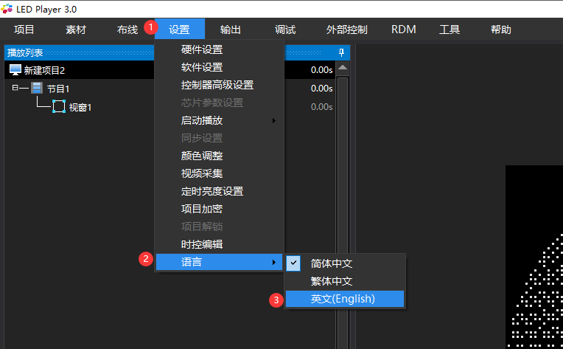
Now, we are ready to make our own pattern, and create our own *.bin file.
- Click Project-New,
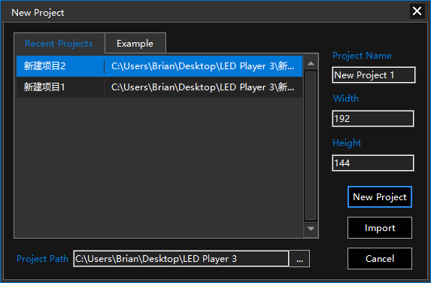
You can name your new project on this window, and set the size of your project, and project file location on your disk. Then click New Project.
- Chose your device type, and IC type on this window, you can also change your project size here again.
* This project size is not same as your LED map, it should be bigger than your LED map, it is a canvas to allow you to put your LEDs on its location.
* If you do not really understand the other options, do not change them!
Click Confirm to continue.

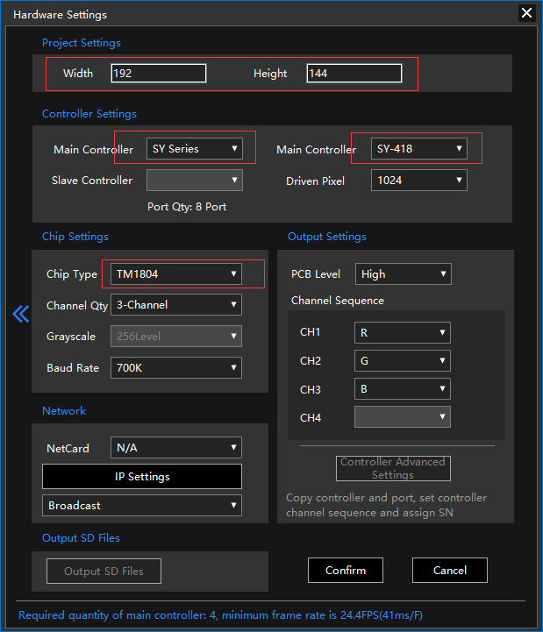

- If your LED map is line or rectangle, you can choose Quick Mapping to set LED map easily.
If you want to draw your LED map manually, you can choose New Map to continue, it will open map tool.
If you have draw your LED map in Autodesk CAD, and exported the *.DWG file to *.DXF, you can choose Import DXF options to insert your *.DXF file to create LED map easily.
If you have created your LED map before, you can choose Import MAP to insert the old map again.
* The option POSI is only for our stuff, do not choose it, if you need our help, please contact our stuff.
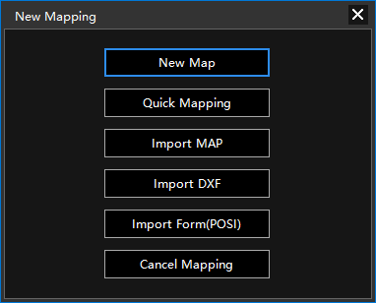
* When you choose Quick Mapping to create your LED map, you can input the width and height of your LED map, and choose right wiring type like your LED, like the picture below:
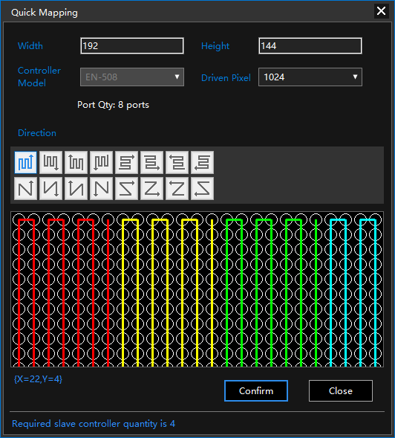
Click Confirm to continue.

*If you want to change your LED map set again when you are making your pattern, you can set it again

- Right click the window name( like window1) to add your effect, like video, swf, text, screen recording, and create your own color wave by “Material List” option.
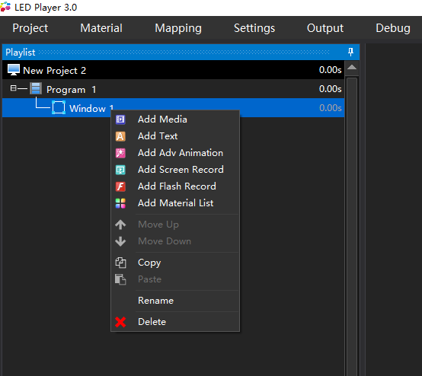
You can quick adjust your effect on the screen right area, like bellow:
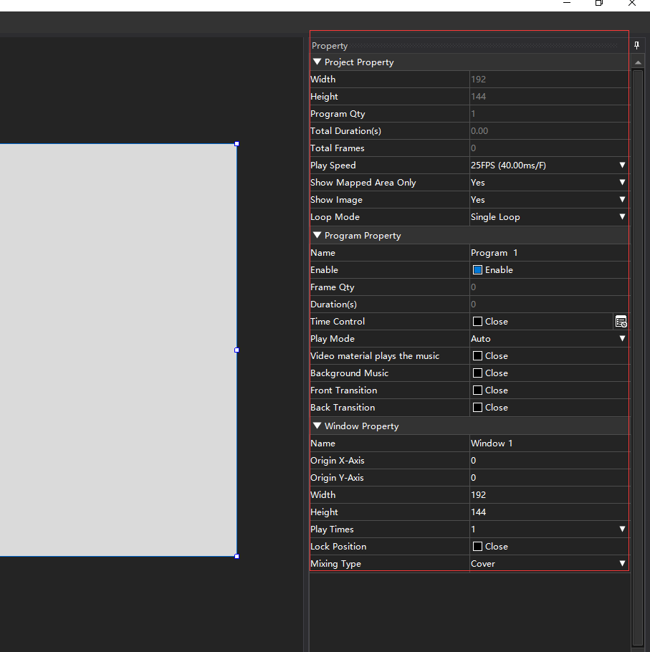
Or double click the effect name to edit your effect, like size, color, speed, etc. Click x on the top right directly, then choose yes to save changing or not to give up.
A compatible project element list is like bellow, it contain project name, program name, window name, and effect name, and time of each option after its name.
* If you found the time is 0, means there is not any effect, please delete it or edit it.
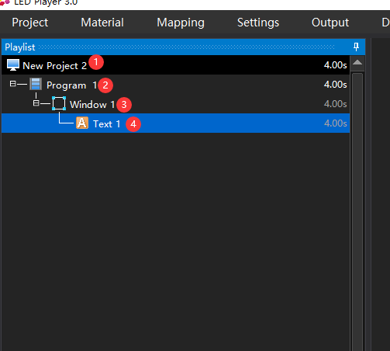
When you choose one effect, you can click the Play button to review it.

- After all patterns create as your need, choose Output to create *.bin file, you can copy this file to SD card for the controller with SD card, like K-SY series,
And video of your pattern to custom for checking and reviewing.
You can also output LED map, and wire drawing to help Construction workers to install your LED.
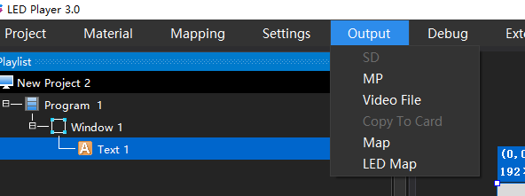

- If your map is to large, it can not full display in the middle area, you can click the Lock button on the top right of the property window, to hide it to side.
