|  |
| --- |
|  |
|  | IMG_256 |

毕业论文(设计)

题目：

|  |  |  |
| --- | --- | --- |
| 分校（教学点） | ： |  |
| 专 业 | ： |  |
| 年级 | ： |  |
| 学号 | ： |  |
| 姓名 | ： |  |
| 指导教师 | ： |  |

年 月 日

**毕业论文（设计）诚信声明**

本人所呈交的毕业论文（设计），是在指导教师指导下进行研究工作所取得的成果，所有数据、图片资料均真实可靠。除文中已经注明引用的内容外，本毕业论文（设计）的研究成果不包含任何他人已公开发表或者没有公开发表的作品或成果。对本论文（设计）所涉及的研究工作做出贡献的其他个人和集体，均已在文中以明确方式标明。本人完全意识到本声明的法律责任由本人承担。

作者签名： **格式**  日期： 年 月 日

**毕业论文（设计）版权使用授权声明**

本人完全了解广东开放大学关于收集、保存、使用毕业论文（设计）的规定，同意如下各项内容：按照学校要求提交论文（设计）的印刷本和电子版本；学校有权保存论文（设计）的印刷本和电子版，并采用影印、缩印、扫描、数字化或其它手段保存论文；学校有权提供目录检索以及提供本毕业论文（设计）全文或者部分的阅览服务，以及出版毕业论文（设计）；学校有权按有关规定向国家有关部门或者机构送交论文的复印件和电子版；在不以赢利为目的的前提下，学校可以适当复制论文的部分或全部内容用于学术活动。

作者签名：** 格式**  日期： 年 月 日

**摘 要**

商业银行是经营货币业务的金融机构，吸纳存款是商业银行取得经营资本的主要资金来源。银行能获取多少利润值，银行能不能好好的经营和延续都仰仗于存款业务。随着我国金融行业深化改革、利率市场化持续推进，商业银行一方面既要提高自身的有效竞争筹码，另一方面也要不断的扩展市场占有份额，面临巨大的检验。本文通过对商业银行···············，研究了···············， 得到了·········的结论， 期望研究结论对·················有帮助。

**关键词: ·**····；·····；·····

（1）摘要、目录标题：黑体、小二、加粗。

（2）摘要正文、关键词：宋体、小四，1.5倍行距。

（3）目录内容：黑体、小四，1.5倍行距；设置好正文一级、二级、三级标题样式，自动生成目录后，再修改对应格式，目录从正文开始。

（4）论文页码：阿拉伯数字居中，从正文开始连续编码，正文为第1页，一直编到最后。

（5）摘要、目录、正文、参考文献、致谢、附录都要独立起页。

（6）评审表、开题报告内填写内容均宋体、小四、1.5倍行距。

**目 录**

[一、引言 1](#_Toc86995790)

[（一）研究背景和意义 1](#_Toc86995791)

[（二）国内外研究概况 1](#_Toc86995792)

[二、\*\*\*\*\*\*\*\*\*的相关理论概述 2](#_Toc86995793)

[（一）\*\*\*\*\*\*\*\*\* 2](#_Toc86995794)

[（二）\*\*\*\*\*\*\*\*\* 2](#_Toc86995795)

[三、\*\*\*\*\*\*\*\*\*的现状 4](#_Toc86995797)

[（一）\*\*\*\*\*\*\*\*\* 4](#_Toc86995798)

[（二）\*\*\*\*\*\*\*\*\* 4](#_Toc86995799)

[四、\*\*\*\*\*\*\*\*\*存在的问题 7](#_Toc86995800)

[（一）\*\*\*\*\*\*\*\*\* 7](#_Toc86995801)

[（二）\*\*\*\*\*\*\*\*\* 8](#_Toc86995802)

[（三）\*\*\*\*\*\*\*\*\* 10](#_Toc86995803)

[（四）\*\*\*\*\*\*\*\*\* 10](#_Toc86995803)

[五、\*\*\*\*\*\*\*\*\*存在问题的原因分析（问题解决方案研究） 11](#_Toc86995804)

[（一）\*\*\*\*\*\*\*\*\* 11](#_Toc86995805)

[（二）\*\*\*\*\*\*\*\*\* 12](#_Toc86995806)

[（三）\*\*\*\*\*\*\*\*\* 12](#_Toc86995803)

[（四）\*\*\*\*\*\*\*\*\* 13](#_Toc86995803)

[六、\*\*\*\*\*\*\*\*\*的建议（问题解决方案的局限性和先进性） 14](#_Toc86995807)

[（一）\*\*\*\*\*\*\*\*\* 14](#_Toc86995808)

[（二）\*\*\*\*\*\*\*\*\* 15](#_Toc86995809)

[（三）\*\*\*\*\*\*\*\*\* 16](#_Toc86995810)

[（四）\*\*\*\*\*\*\*\*\* 17](#_Toc86995811)

[七、结论 17](#_Toc86995812)

[参考文献 18](#_Toc86995813)

[致 谢 19](#_Toc86995814)

# 引言

一级标题为黑体小二加粗，段前17磅，段后16.5磅，行距为多倍行距、2.41倍，悬挂缩进0.74，见图1.1设样式置。



图1.1 一级标题样式设置

## （一）研究背景和意义

二级标题为黑体小二加粗段前18磅、段后18磅，行距为单倍行距、1倍，见图1.2样式设置。



图1.2 二级标题样式设置

存款是影响宏观经济平衡的重要变量，是权衡商业银行实力与发展情况的核心指标之一。商业银行存续依赖存款业务。在商业银行经营商中，存款量的多少决定了商业银行获取利润规模的大小。

正文为小四宋体，行距1.5倍，首行缩进2字符，见图1.3样式设置。

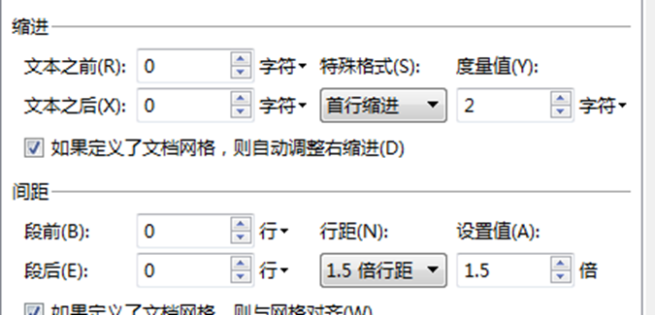

图1.3 正文样式设置

····································································································································································································································································。

## （二）国内外研究概况

针对银行企业的存款业务，建议银行企业首先加强与财务公司业务合作；其次转变银行经营理念，重在增加客户群，提高目前的客户质量；同时她还强调要积极提高客户管理水平[1]。

····································································································································································································································································。

# \*\*\*\*\*\*\*\*\*的相关理论概述

## （一）\*\*\*\*\*\*\*\*\*

银行存款是商业银行和各类金融机构，收到企事业单位、机关团体等组织机关或者其···································································································································································································································································。

## （二）\*\*\*\*\*\*\*\*\*

### 1. 存款稳定率理论

三级标题为黑体小四加粗段前12磅、段后12磅，行距为单倍行距、1倍，悬挂缩进0.64厘米，见图1.4样式设置。

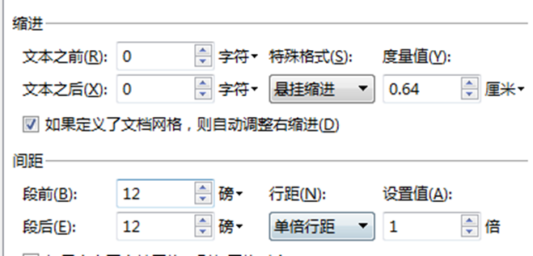

图1.4 三级标题样式设置

存款稳定率，是指商业银行在特定时间里，留存银行的所有存款中最比较稳定的一部分和留存银行的存款净额之间的比值。存款稳定率是反映银行存款稳定性的主要指标，是反映银行存款期限长短的重要关键，是银行掌握新增信贷总额的重要数据源泉。

······································································································································································································································································。

### 2. 存款风险理论

存款风险一般是指银行在经营活动中因为经营存款业务给银行造成的不确定损失。存·····································································································································································································································································。

# \*\*\*\*\*\*\*\*\*的现状

## （一）\*\*\*\*\*\*\*\*\*

珠海农村商业银行股份有限公司（简称“珠海农商银行”）是珠海第一家银行。珠海农商银行创立于1952年，2012年12月改制为商业银行，如今珠海农商银行已经是有独立法人资格的股份制商业银行。七十年来，珠海农商银行一直为珠海三农、小微企业和·····································································································································································································································································。

## （二）\*\*\*\*\*\*\*\*\*

如表1珠海农商银行年报披露的数据所示，截止2020年末，该行资产总额为637.25亿元，负债总额582.19亿元，净利润额5.1亿元。资产总额增加35.67亿元，增速为5.93%；负债总额比年初增加32.45亿元，增速为5.90%；净利润比年初下降0.58亿元，净利润下降10.31%。

表1 珠海农商银行资产负债净资产表（单位：亿元）

|  |  |  |  |  |  |  |  |
| --- | --- | --- | --- | --- | --- | --- | --- |
| 项目 | 2021 | 2020 | 2019 | 2018 | 2017 | 2016 | 2015 |
| 总资产 | 624.85 | 637.25 | 601.58 | 595.74 | 583.69 | 506.10 | 409.18 |
| 增速 | 6.54% | 5.93% | 0.98% | 5.69% | 11.38% | 23.69% | 12.38% |
| 总负债 | 570.48 | 582.19 | 549.73 | 544.60 | 515.84 | 461.52 | 367.24 |
| 增速 | 6.46% | 5.90% | 0.94% | 5.58% | 11.77% | 25.67% | 12.50% |
| 营业收入 | 7.50 | 16.02 | 12.82 | 15.04 | 14.27 | 13.45 | 13.65 |
| 增速 | -6.72% | 11.28% | 5.20% | 5.40% | 6.10% | -1.47% | 13.66% |
| 净利润 | 2.66 | 5.10 | 5.68 | 5.55 | 5.62 | 5.15 | 5.05 |
| 增速 | 5.56% | -10.31% | 2.37% | -1.25% | 9.13% | 1.98% | -10.62% |

数据来源：珠海农商银行2013-2020年报

表格居中，表的标注在表上居中，连续编号，如表1 、表2等，表的标注字体为宋体、5号，表内字体宋体5号。用到的表需在正文中给出说明。

·····································································································································································································································································。

在农商银行的客户存款结构及存款总额表中可以看出，个人定期存款的数额在存款中的数额是最多，其次是公司活期数额、个人活期数额与公司定期存款数额（见图1）。

图1 客户存款数额（单位：亿元）

数据来源：珠海农商银行2013-2020年报

图居中，图的标注在图下居中，连续编号，如图1 ，图2等，图的标注字体为宋体、5号，图内的字体宋体5号。用到的图需在正文中给出说明。

·····································································································································································································································································。

# 七、结论

商业银行作为信用中介，存款规模是一家商业银行的经营情况的一个考核标准，展示··········································································。

# 参考文献

[1]杨志坚.中国远程高等教育发展研究报告:2012[M].北京：中央广播电视大学出版社，2013年4月:36-37.

[2]赵鹏,杨浩.京沪高速铁路列车开行模式的研究[J].北京交通大学学报, 2006(3):5-9.

[3]李瑞.互联网金融对中国商业银行个人存款业务的影响研究[D].东北师范大学,2018.

[4]Michael R.Bussieck,PeterKreuzer.Optimal lines for railway systems[J].European Journal of OperationalResearch,1996(96),54-63.

·····································································································································································································································································。

（1）参考文献、致谢、附录标题：黑体、小二、加粗。

（2）参考文献内容：宋体、五号、1.5倍行距；参考文献最低10条左右，大部分近3-5年内文献。

（3）致谢、附录：宋体、小四、1.5倍行距。

# 致 谢

本论文是在\*\*老师的悉心指导下完成，选取课题到论文的框架确定再到修改到最后的····································································································································································································································································。

# 附 录